[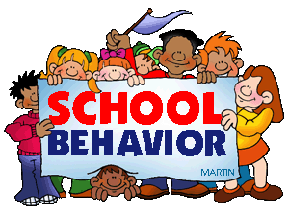](https://www.google.com/url?sa=i&rct=j&q=&esrc=s&source=images&cd=&cad=rja&uact=8&ved=0ahUKEwjO3JfGvN_OAhXH7SYKHY7eC3UQjRwIBw&url=http://themes.pppst.com/schoolbehavior.html&bvm=bv.131286987,d.eWE&psig=AFQjCNHZoCtkKiX-juYOEX36q0N9LCTJAA&ust=1472314360420084)

**Behavior Contract**

**Fifth Grade Rules**

**S- SAFE** -Walk in the classroom/halls

-Sit quietly

-Think before you act

**T- TEAM PLAYER** -Wait your turn

-Listen to others

-Help others in need

**A- ACHIEVER** -Do your very best

-Follow directions their first time

-Push yourself to be great

**R-RESPECTFUL** -Keep your hands/feet to yourself

-Use kind words

-Be respectful to EVERYONE!

**Fifth grade Consequences (Three strikes = out of half of Fun Friday. Six strikes = out of all of Fun Friday. **We will have some sort of activity or incentive every Friday for Fun Friday.)**

* Verbal warning
* Negative Dojo Points
* Note sent home in planner (parent signature required) or dojo message
* Phone call home
* Time out in another room
* Principal referral

-----------------------------------------------------------------------------------------------------------------------------

**Behavior Policy Contract**

I have read this behavior policy and have discussed it with my child.

______________________________________ ____________________________________

Parent’s signature Student’s signature

____________________________

Date